
Year 10

Pathway 2

Mini Test 7 – Trigonometry

Name: Total Marks: /44
Date: Total Time: 45 minutes

Marks will be allocated for working out. Read the questions carefully.

- Use the tan ratio to find the length of side $x$: (2 marks)

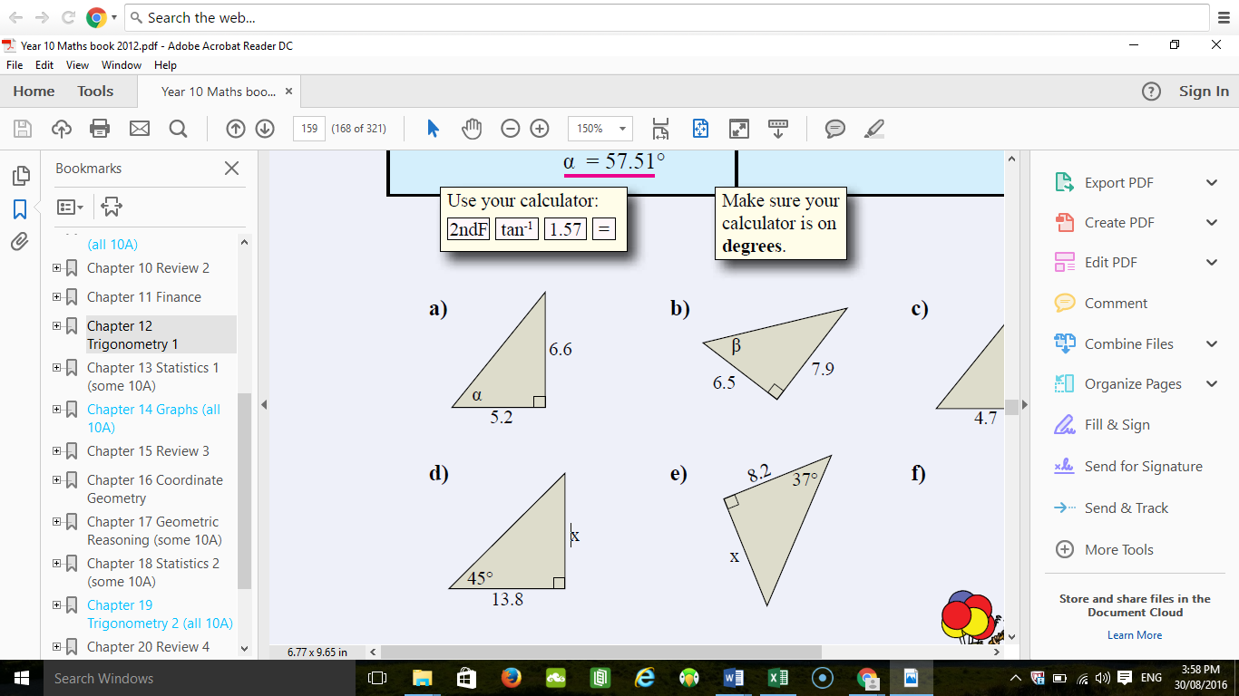

- Use the sine ratio to find the length of side $x$: (2 marks)

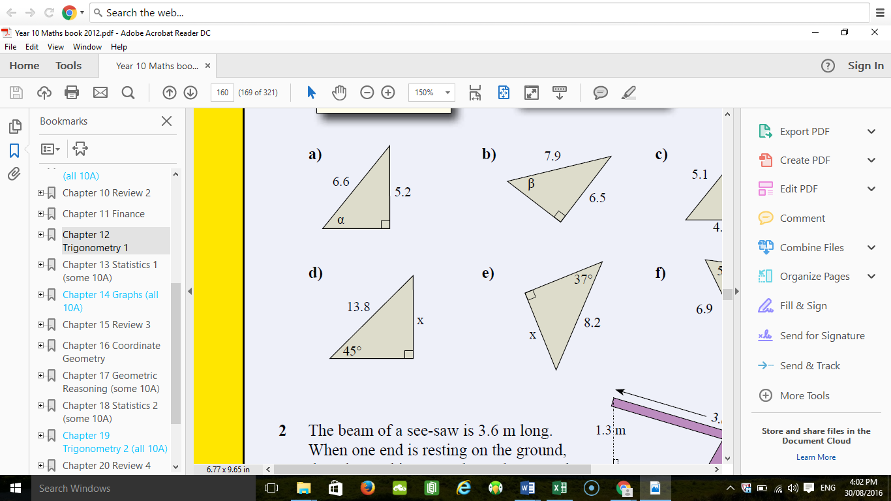

- Use the cos ratio to find the size of angle a: (2 marks)

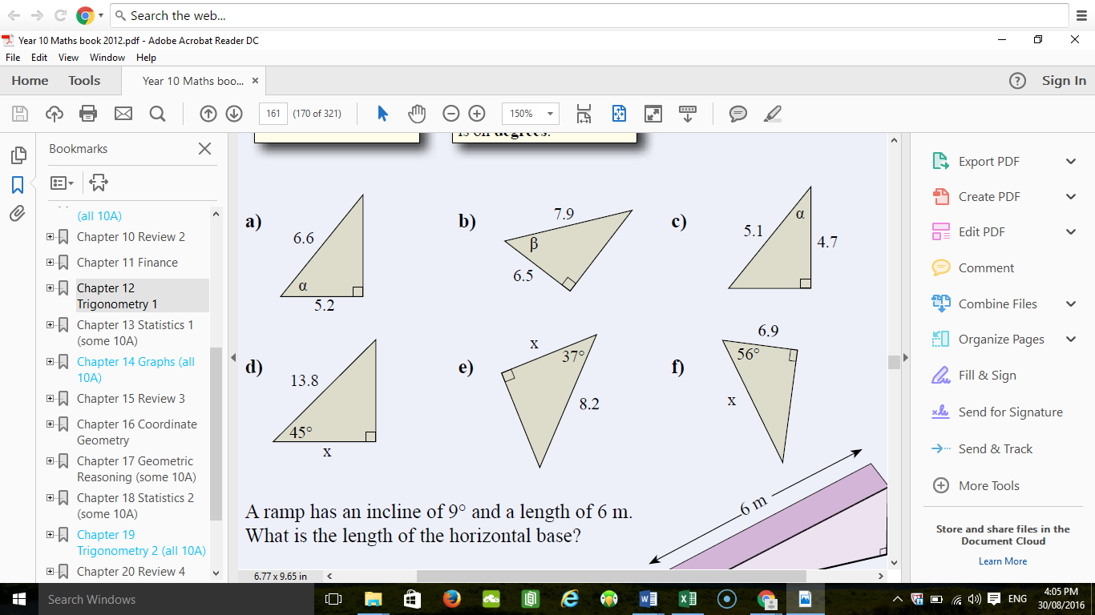

- For each of the following, find the value of x correct to two decimal places.
label sides (1 mark), choose the correct trigonometric ratio (1 mark),
show all working out before solving (2 mark) (16 marks)

a b
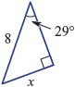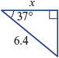

c d
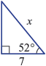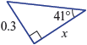

- Find the value of θ to the nearest degree.
Choose the correct trigonometric ratio (1 mark), show all working out before solving (2 mark) (6 marks)

a b
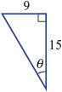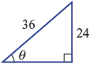

- Sketch a right angle triangle which has an angle of 30º and a hypotenuse of 12cm. Find the lengths of the other two sides. Round to the first decimal point. (3 marks)

- Sketch a different right angled triangle with an angle of 30º where the hypotenuse is not equal to 12cm. Write on possible lengths of the sides. (3 marks)

- A surveyor measures the angle to the top of a peak from a point 250 m away to be 39˚. How high is the peak? (2 marks)
Hint: Draw a diagram.

- At 72 metres in height, Gloucester Tree in Pemberton, is the world's second tallest fire-lookout tree (second only to the nearby Dave Evans Bicentennial Tree), and visitors can climb up to a platform in its upper branches for a spectacular view of the surrounding karri forest. The angle of depression from the top of the platform is 42º when looking to where someone stands on the ground. (4 marks)

- Draw an appropriate diagram that shows all of the relevant information from the scenario above.

- Calculate the distance of the person on the ground from the base of the tree.

END OF TEST

